Programming IN JAVA

NAME : MOTHISHWARAN.C

REG NO : 19MID0017

SLOT : L35+L36

ASSESSMENT NO : 04

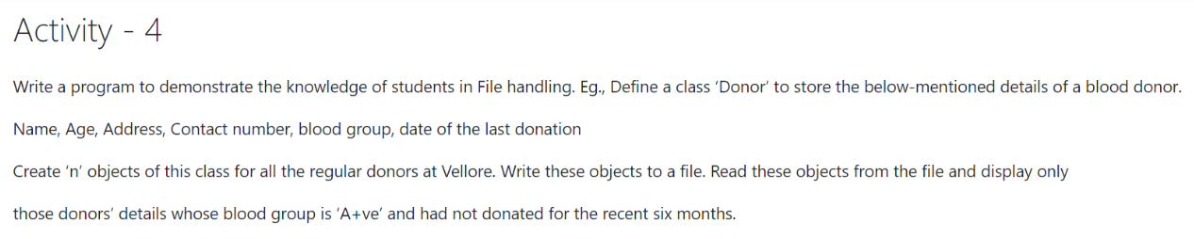

Source code:

package files;

import java.io.FileInputStream;

import java.io.FileNotFoundException;

import java.io.FileOutputStream;

import java.io.IOException;

import java.io.ObjectInputStream;

import java.io.ObjectOutputStream;

import java.io.Serializable;

import java.text.ParseException;

import java.util.Date;

import java.text.SimpleDateFormat;

import java.util.Calendar;

import java.util.Scanner;

/**

*

* @author mothi

*/

class Donor implements Serializable

{

String name;

int age;

String address;

long contact_no;

String blood_group;

Calendar last_donated_date=Calendar.getInstance();

SimpleDateFormat formatter= new SimpleDateFormat("dd/MM/yyyy");

Donor(String name,int age,String address,long contact_no,String blood_group,String date1)

{

this.name=name;

this.age=age;

this.address=address;

this.contact_no=contact_no;

this.blood_group=blood_group;

try{

Date date=formatter.parse(date1);// parsing(separeting) the date string

last_donated_date.setTime(date);// date to calender object

}

catch(ParseException e)

{

System.out.println("Not a valid date ");

}

}

@Override

public String toString()

{

return "Name: "+name+

"\nAge: "+age+

"\nAddress: "+address+

"\nContact_no: "+contact_no+

"\nBlood Group: "+blood_group+

"\nDate: "+formatter.format(last_donated_date.getTime())+//Calendar to String

"\n---------------------------------------------------------";

}

}

public class donor_file {

public static void main(String args[]){

Scanner in =new Scanner(System.in);

String name;

int age;

String address;

long number;

String blood_group;

String date;

System.out.println("19MID0017-Mothishwaran.C\nSerializing..........\n"

+ "Constrints : blood group should be 'A+ve' & shouldn't be donated for last six months");

System.out.print("Enter the number of Donors: ");

int Donors_no=in.nextInt();

Donor[] d; // array of donor reference

d = new Donor[Donors_no];

try

{

FileOutputStream fos=new FileOutputStream("E:\\Java_Practice\\Files\\Donor_Details");

ObjectOutputStream oos = new ObjectOutputStream(fos);

for (int i=0;i<Donors_no;i++)

{

System.out.println("Please enter the details for Donor-"+(i+1));

System.out.print("Enter name : ");

name=in.next();

System.out.print("Enter age : ");

age=in.nextInt();

in.nextLine();

System.out.print("Enter address : ");

address=in.nextLine();

System.out.print("Enter mobile number : ");

number=in.nextLong();

System.out.print("Enter blood group : ");

blood_group=in.next();

System.out.print("Enter date of last donation : ");

date=in.next();

d[i]=new Donor(name,age,address,number,blood_group,date);

oos.writeObject(d[i]);

oos.flush();

}

oos.close();

}

catch(FileNotFoundException fnfe)

{

System.out.println("During Serialization, error occured due to "+fnfe);

}

catch(IOException ioe)

{

System.out.println("During Serialization, error occured due to "+ioe);

}

System.out.println("\n========================================================="

+ "\nDeserializing......\n");

try{

FileInputStream fis=new FileInputStream("E:\\Java_Practice\\Files\\Donor_Details");

ObjectInputStream ois = new ObjectInputStream(fis);

Calendar six_month = Calendar.getInstance();

six_month.add(Calendar.MONTH,-6);//getting the instance of six month ago calendar

Donor []d2;

d2 = new Donor[Donors_no];

int count=0;//flag to check presence of data

System.out.println("Details of Donors with 'A+ve' & didn't donate on past six months .......\n");

for (int i=0;i<Donors_no;i++)

{

d2[i] = (Donor) ois.readObject();

//constraint

if((d2[i].blood_group).equals("A+ve") && (d2[i].last_donated_date).compareTo(six_month)<=0)

{

System.out.println(d2[i]);

count++;

}

}

ois.close();

if(count==0)// executed when no data is found for the constraint

{

System.out.println("No Data Found");

}

}

catch(FileNotFoundException fnfe)

{

System.out.println("During Deserialization, error occured due to "+fnfe);

}

catch(IOException | ClassNotFoundException e)

{

System.out.println("During Deserialization, error occured due to "+e);

}

System.out.println("\n=========================================================");

}

}

Output:

1)

run:

19MID0017-Mothishwaran.C

Serializing..........

Constrints : blood group should be 'A+ve' & shouldn't be donated for last six months

Enter the number of Donors: 4

Please enter the details for Donor-1

Enter name : Mc

Enter age : 20

Enter address : 12,vit,vellore

Enter mobile number : 9876543210

Enter blood group : A+ve

Enter date of last donation : 15/11/2020

Please enter the details for Donor-2

Enter name : mc1

Enter age : 20

Enter address : 21,vit,vellore

Enter mobile number : 9876543211

Enter blood group : O+ve

Enter date of last donation : 19/10/2020

Please enter the details for Donor-3

Enter name : mc2

Enter age : 20

Enter address : 15,vit,vellore

Enter mobile number : 9876543212

Enter blood group : A+ve

Enter date of last donation : 15/01/2021

Please enter the details for Donor-4

Enter name : Mothish

Enter age : 20

Enter address : 17,vit,vellore

Enter mobile number : 9876543213

Enter blood group : A+ve

Enter date of last donation : 01/07/2020

=========================================================

Deserializing......

Details of Donors with 'A+ve' & didn't donate on past six months .......

Name: Mc

Age: 20

Address: 12,vit,vellore

Contact_no: 9876543210

Blood Group: A+ve

Date: 15/11/2020

---------------------------------------------------------

Name: Mothish

Age: 20

Address: 17,vit,vellore

Contact_no: 9876543213

Blood Group: A+ve

Date: 01/07/2020

---------------------------------------------------------

=========================================================

2)

run:

19MID0017-Mothishwaran.C

Serializing..........

Constrints : blood group should be 'A+ve' & shouldn't be donated for last six months

Enter the number of Donors: 2

Please enter the details for Donor-1

Enter name : Mc

Enter age : 20

Enter address : 17,VIT,VELLORE

Enter mobile number : 9876543214

Enter blood group : O+ve

Enter date of last donation : 15/03/2020

Please enter the details for Donor-2

Enter name : Mothish

Enter age : 20

Enter address : 17,scope,vit,vellore

Enter mobile number : 9876543215

Enter blood group : A+ve

Enter date of last donation : 01/01/2021

=========================================================

Deserializing......

Details of Donors with 'A+ve' & didn't donate on past six months .......

No Data Found

=========================================================

BUILD SUCCESSFUL (total time: 1 minute 16 seconds)

Code snip:

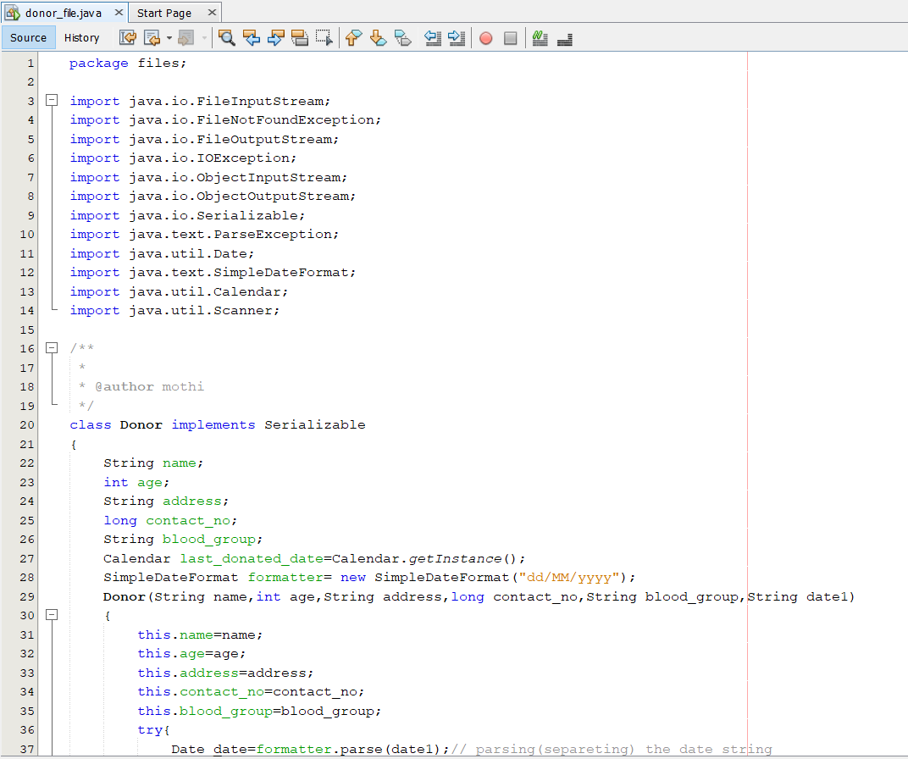 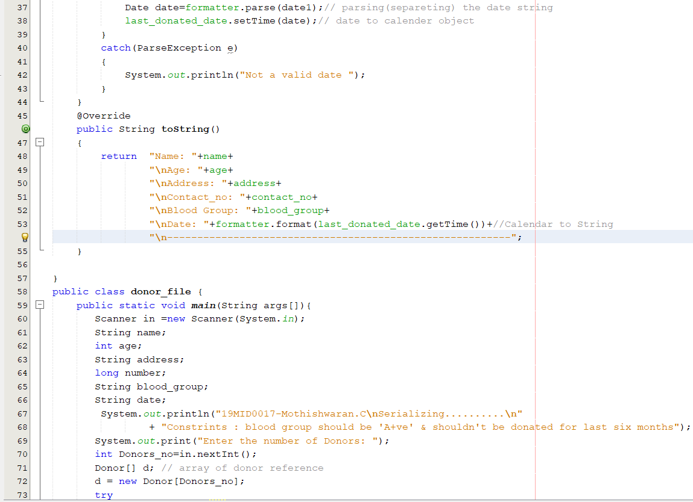

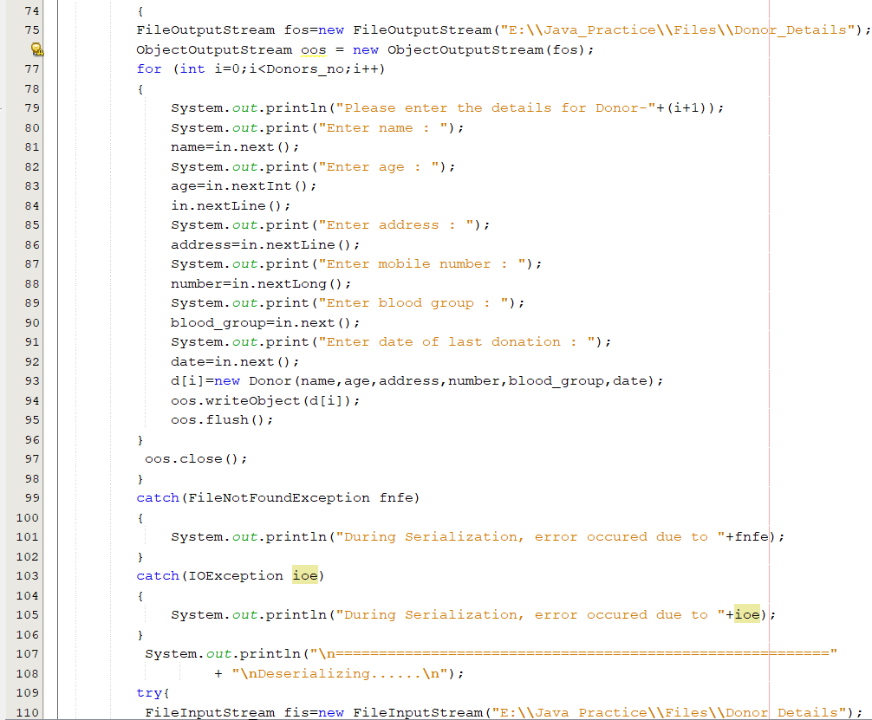 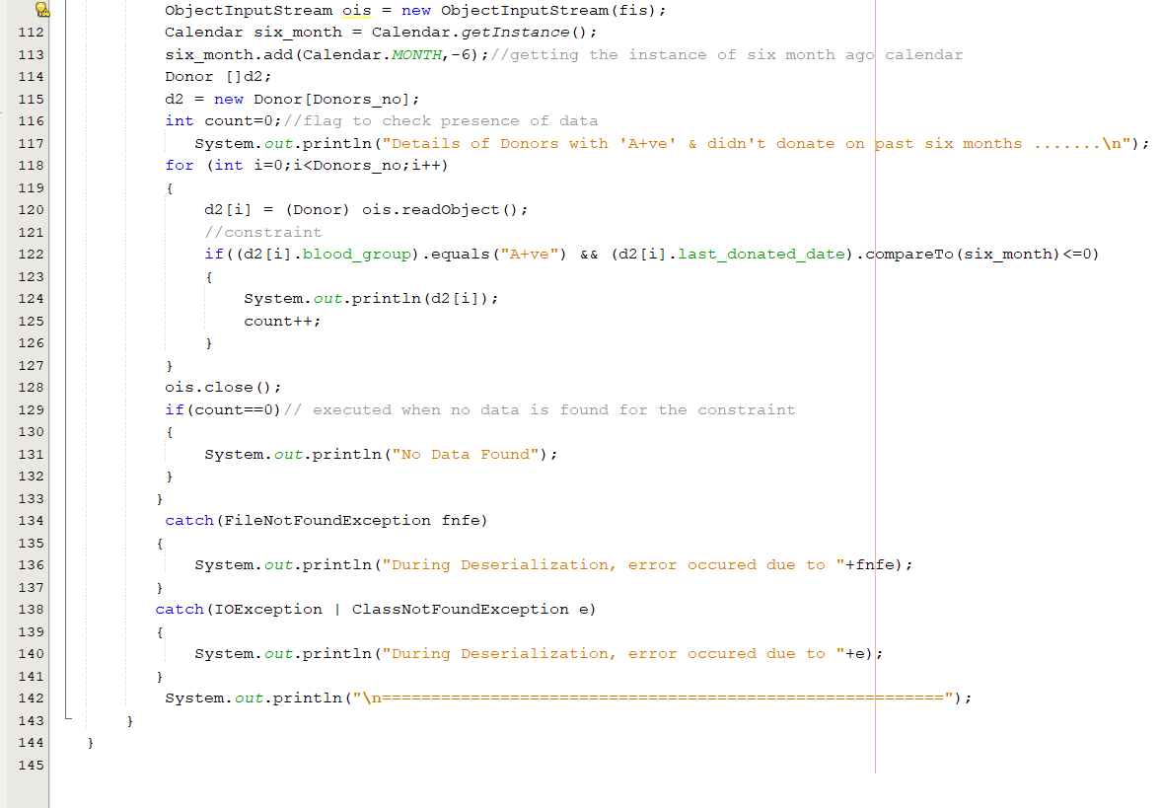

Output snip:

1. Before Execution:

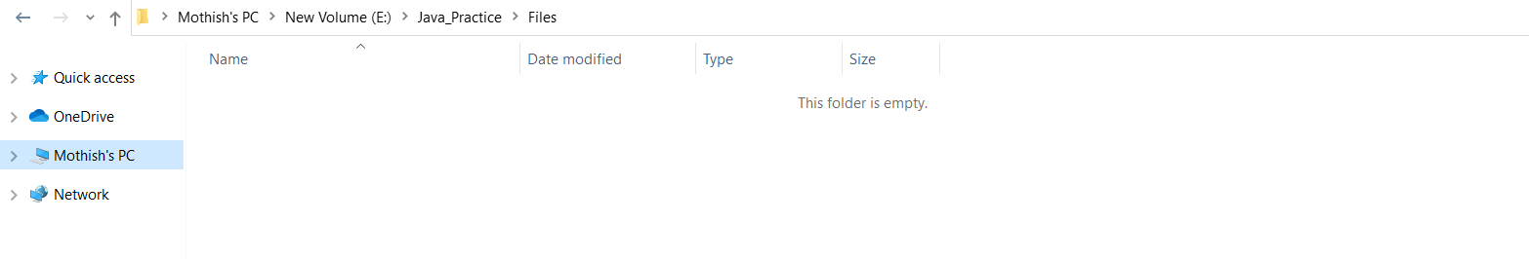

After Execution:

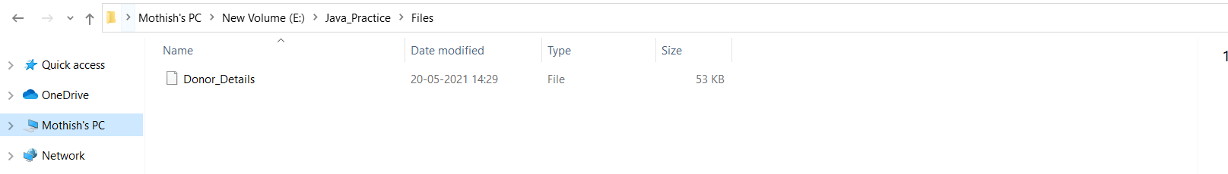

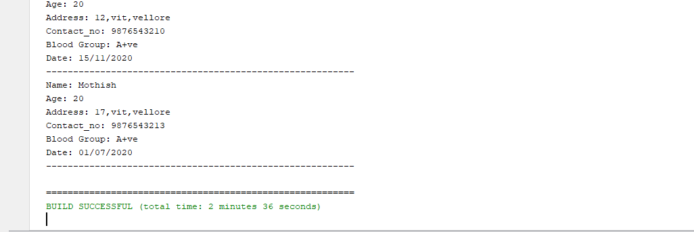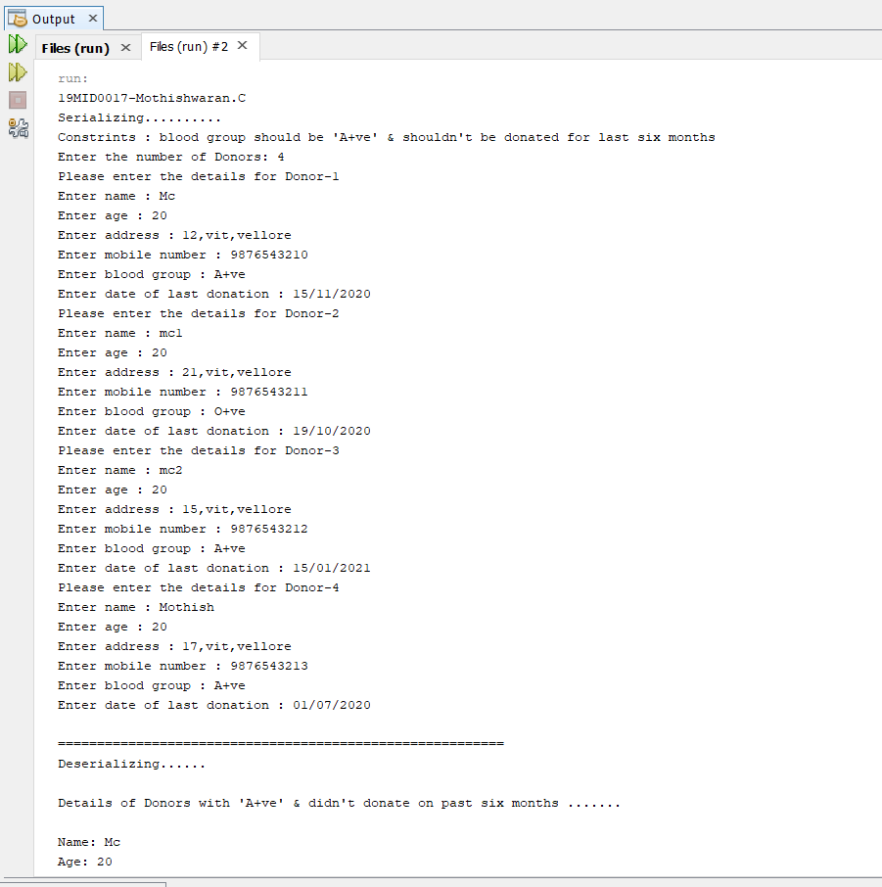

1. Before Execution:

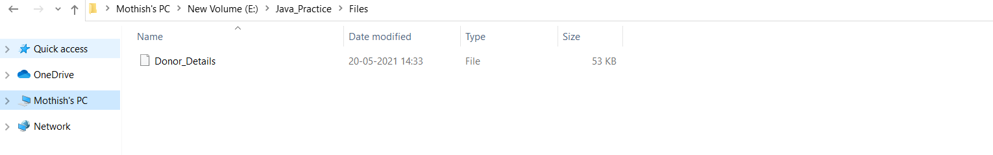

After Execution:

